EXPERIMENT 3
ROLL NO:240701817 NAME: S.NITHISH KUMAR
Create a prototype with familiar and unfamiliar navigation elements. Evaluate ease of use with different user groups using proto.io
1) Home Screen:

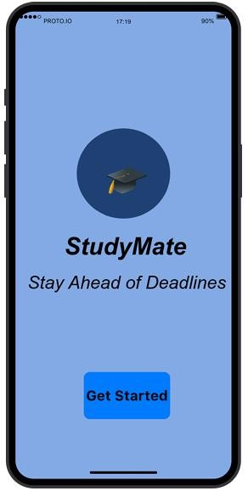

Familiar Elements:
- App Logo (Center):
  - Most mobile apps display logo in the center during launch. o Users recognize this as the starting screen.
- “Get Started” Button:
  - Common call-to-action button used in onboarding screens.
  - Clicking it takes the user to the next screen.
- Center Aligned Layout:
  - Many apps use centered content for welcome screens. o Easy to understand and visually balanced.
Possibly Unfamiliar Elements:
- Minimal Design Without Skip Option:
  - Some apps provide multiple onboarding slides.
  - Here only one simple welcome screen is used.
- Blue Theme Background: o Though common, users may associate different colors with productivity apps.
2) Login Screen :
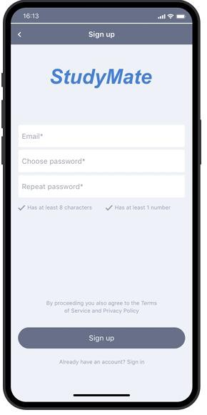

Email Text Field:
- Standard input field for login.
- Used in almost all applications.
- Password Field (Hidden Characters): o Common security feature. o Characters are hidden for privacy.
- Login Button:
  - Widely recognized call-to-action button.
  - Clicking it navigates to dashboard.
- Error Message in Red:
  - Red color commonly indicates error. o Helps users identify mistakes.
Possibly Unfamiliar Elements:
1. No “Forgot Password” Option: o Many apps provide password recovery. o Its absence may feel slightly different.

3) Dashboard Screen:
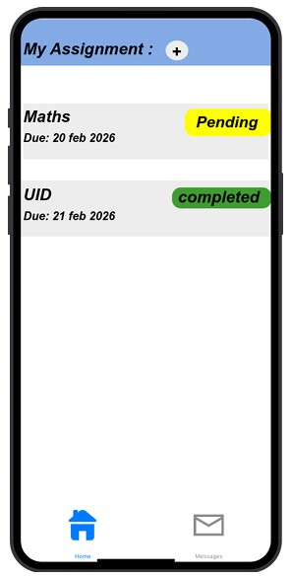

Card Layout for Assignments:
- Commonly used in task and productivity apps.
- Displays subject, deadline, and status clearly.
- Plus (+) Icon:
  - Universally recognized for adding new items.
  - Clicking it allows adding assignment.
- Bottom Navigation Bar:
  - Standard mobile navigation pattern.
  - Includes Home and Profile options.
- Status Labels (Pending / Completed):
  - Clearly shows task condition. o Similar to to-do list apps.
Possibly Unfamiliar Elements:
- Color-coded Status (Yellow/Green): o Some users may take time to understand meaning of colors.
- No Separate Add Screen (if popup used): o Some apps open a new page instead of inline action.
4) Profile Screen
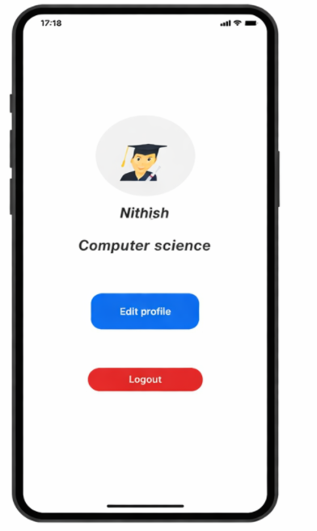

Circular Profile Image:
- Common UI pattern for user identity.
- Used in most social and productivity apps.
- Edit Profile Button: o Standard option for updating personal details.
- Logout Button:
  - Common account management feature.
  - Clicking logs out of application.
- Toggle Switch (Dark Mode): o Familiar UI element for enabling/disabling features Possibly Unfamiliar Elements:
1. Dark Mode Inside Profile Page:
o Usually placed under Settings in some apps. o Placement here may be slightly different.

